**Memory Allocation:**

In c++, we have to deallocate the memory address manually unlike the other languages like

**Class & object :**

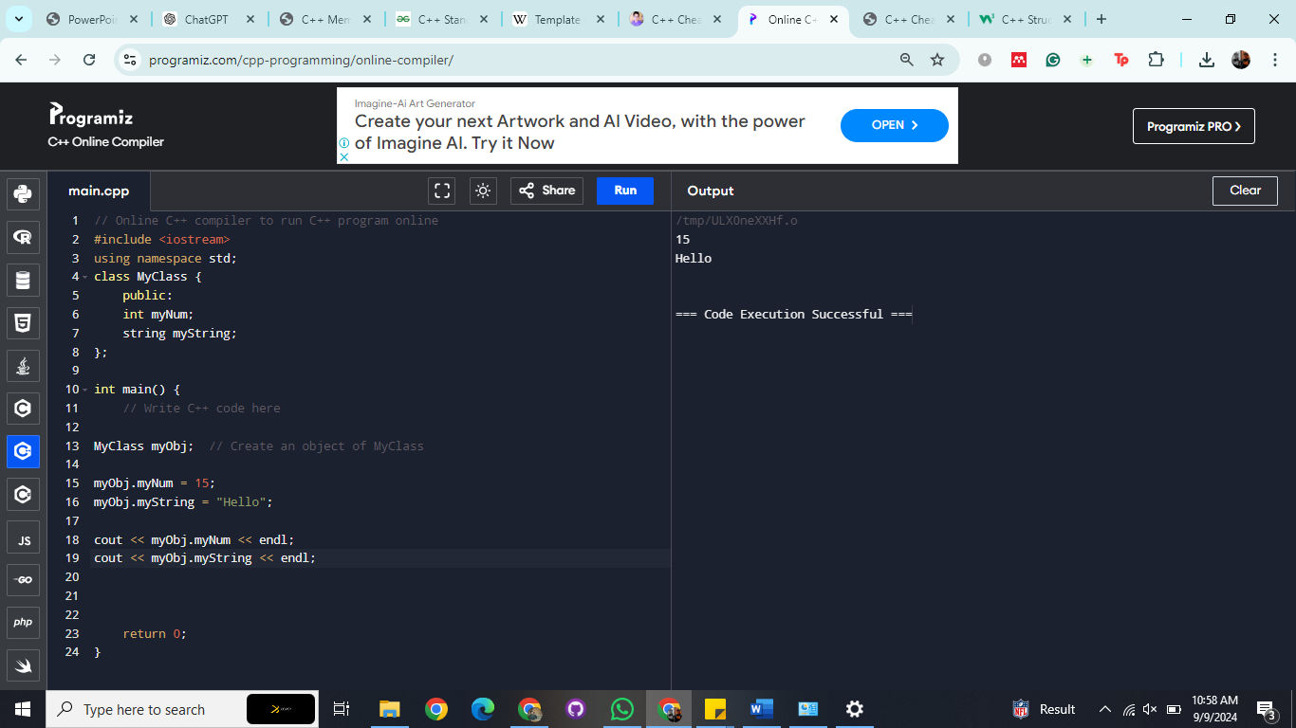

**Structure**

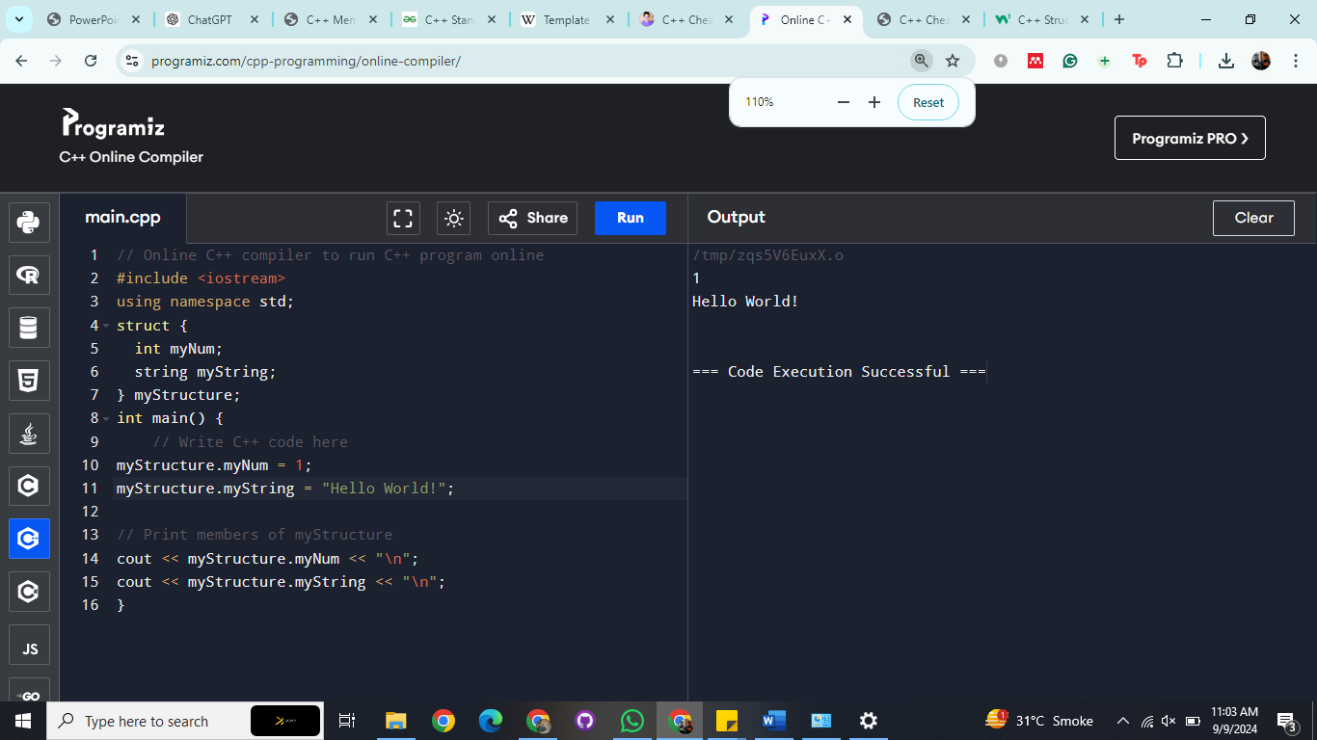

**Inheritance:**

